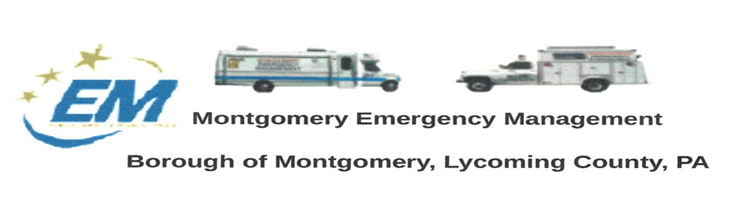

**Greg Gruver, EMA Coordinator. 77 East Houston Avenue, Montgomery, PA 17752**

Telephone: 570-547-1212 Cell: 570-419-4866 Email: [monteman61@gmail.com](mailto:monteman61@gmail.com)

**Fae Herb, Administrative Assistant. 102 Broad Street, Montgomery, PA 17752**

Cell: 570-506-9892 Email: [faeherb@aol.com](mailto:faeherb@aol.com)

Meeting Room and Equipment Building: 40 Thomas Avenue, Montgomery, PA 17752

Borough EOC: 570-547-1671 Fire Hall EOC: 570-547-1380

**INTERNET WEBSITE: www.montgomeryboroughema.org**

**The next regular meeting** of the Montgomery Borough Emergency Management Agency will be:

**THURSDAY,JULY 14, 2021 AT 7 P.M.**

**REFRESHMENTS WILL BE PROVIDED BY ED FERGUSON**

**NOTES FROM ADMINISTRATIVE ASSISTANT, FAE HERB**

Living in a community, next to a river is a wonderful resource. The EMA was recently gifted an inflatable boat to be

used in such emergencies as high water rescues, river rescues. We are in the process of changing ownership and

obtaining the registration. Arrangements have been made to decal the boat once everything is changed over.

Greg heads our water rescue team and trains with them several times throughout the year. Volunteers are always

Welcomed and should contact Greg if you would like to help out.

. The month of May was filled with activities that the people are glad to enjoy the outdoor once again. A big thanks

To Les Gruver for keeping us posted on social media of not just upcoming rain storms and wind storms, but he slips

In a “ray of sunshine” report, which makes us smile. Some of the past events the EMA took part in were the Easter

Egg hung, Fishing Derby, Memorial Day. With more upcoming events such as Riverfest on Saturday June 18th and

The Fireworks scheduled for Sunday, July 3rd.

Greg and Dennis keeps the members informed on the Little League bridge replacement status. The duo also informs the

Borough about the brush that needs to be cleared in the stream areas so as not to cause issues should the water

Rise.

We enter the month of June, and many residents share their memories of 50 years ago. Hurricane Agnes. River rose to

37.45 feet…17.45 feet above flood stage in Montgomery. After the water went down, the community of Montgomery

Was one of the first areas to rally together and clean up from the aftermath. Two of my brothers, who were teenagers

At the time volunteered their time to help others. At the age of 10, I was shoveling mud and throwing flood damaged

Items out. VOLUNTEERS ARE ALWAYS NEEDED, TRAIN, BE PREPARED. NO MATTER YOUR AGE !!!